This provides documentation as to how we formatted our data before uploading it to our database, in a couple of steps.

- As we did this by hand, technically we could have received it in any format, such as the example below:
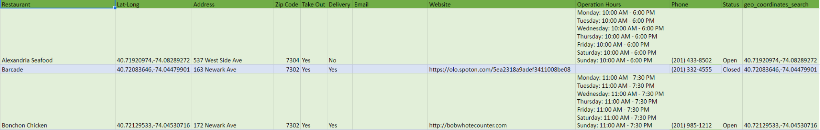
- After receiving this, I created a new document in the ‘Location Docs’ portion of the Google Drive, labeled ‘MongoDBFormatDatasheet’ which is the final form factor required for the manual MongoDB upload via the mongoimport command – as found in the Database Import Specfication Document.
- In the case above, I copied the ‘Lat-Long’ column, and pasted it into the document specified above. Though the form (Lat,Long) was not exactly what I needed it to be, it was solved by simply:
  - In the Format Datasheet, visit the ‘Data’ tab up top.
  - Then select ‘Split text to Columns’
    - I have the Separator set to ‘Detect Automatically’, so steps below were not necessary.
  - In the Convert Text to Columns Wizard, selected ‘Delimited’, then ‘Next’
  - We then specify the Delimiters necessary, in our case it was a comma.
  - Select ‘Next’, then ‘Destination’, then ‘Finish’.

